A Multi-model Machine Learning Architecture for Food Supply Chain Segmentation and Optimization in Makerere University Food Operations.
SW-ML-17
RUGAMBWA GLORIA, AINEMBABAZI MARTINA and NAMITTO MARIA LEODESCA
Department of Computer Science, COCIS, Makerere University, Kampala, Uganda
Supervisor: Ggaliwango Marvin
ABSTRACT This paper presents the design, data description, exploratory analysis, model assessment, and deployment of a Smart Food Chain Management System for restaurants and food vendors operating in and around Makerere University, Uganda. Two synthetic datasets, the cafeteria production dataset and the kiosk production dataset, were generated to reflect known Ugandan food consumption patterns and the university's academic calendar. Structured exploratory data analysis across the datasets documents demand-supply mismatches, waste-induced financial losses, temporal consumption variability, and transaction dynamics. The study evaluates four clustering models: HDBSCAN, Spectral Clustering, Agglomerative Clustering, and BIRCH. The final deployment exposes the HDBSCAN model through a FastAPI service, using live preprocessing and approximate prediction to provide supply actions that can reduce waste, improve vendor profitability, and stabilize service reliability across campus food operations.
INDEX TERMS: food supply chain management, synthetic data, unsupervised clustering, HDBSCAN, spectral clustering, agglomerative clustering, BIRCH, waste reduction

From a computational perspective, this research formulates a supply chain optimization problem with two outputs: operational segmentation and cluster-based procurement guidance. The system processes structured temporal and tabular data under a sim-to-real transfer learning constraint because the primary training corpus is synthetically generated. The inductive biases therefore combine four clustering approaches: HDBSCAN for density-based grouping and noise detection, Spectral Clustering for graph-based partitioning, Agglomerative Clustering for hierarchical grouping, and BIRCH for scalable incremental clustering. In the deployed component, the HDBSCAN clustering model is exposed as a service that can classify new cafeteria-day records and return practical procurement advice.
Traditional supply chain analysis often begins with forecasting-oriented heuristics such as moving averages and linear autoregression, but the Makerere food operations data in this study are being used primarily for clustering and segmentation. Modern predictive pipelines therefore need clustering models that match the geometry of the data: HDBSCAN for density-based separation, Spectral Clustering for non-linear partitions, Agglomerative Clustering for hierarchical structure, and BIRCH for compact scalable grouping.
II. BACKGROUND AND LITERATURE REVIEW
Conversely, to capture complex, structured operational similarity across cafeteria days, clustering methods are required rather than pure sequence models. By integrating the distinct clustering families, this study bridges the gap between static inventory tracking and dynamic, context-aware demand segmentation.
III. COMPUTATIONAL PROBLEM STATEMENT
While multi-model clustering pipelines provide high theoretical value, the underlying machine learning bottleneck in this operational context lies in mitigating the Sim-to-Real Domain Shift.
What: Due to the absence of comprehensive real-time Iot tracking at the site, the primary training corpus consists of synthetically simulated temporal transaction data.
Symptoms: When models are trained only on synthetic distributions and then applied directly to live operations, they may project idealized cluster boundaries that miss real-world stochasticity. In this setting, the operational penalty appears as incorrect day-type classification, which can lead to overproduction, understocking, or unnecessary manual rework.
When and Why: This optimization failure occurs because the gradient descent algorithm inevitably overfits the latent mathematical rules used by the synthetic data generator. The model learns a ‘clean’ representation of demand that lacks the spurious noise, weather anomalies, and human irrationality inherent in actual university cafeterias.
Solution: Consequently, the computational architecture cannot blindly trust the synthetic weights. The system must explicitly enforce a continuous online-learning or domain adaptation pipeline, treating the synthetic training phase solely as a parameter initialization(pre-training) step. Live deployment must incorporate localized fine tuning on rolling-window empirical data to safely align the predictive boundaries with real-world cafeteria stochasticity.
IV. DATASET DESCRIPTION AND TEMPORAL DATA DISCIPLINE
The predictive corpus utilizes two synthetically modeled distributions reflecting Makerere University’s food service operations: a cafeteria production dataset (tracking the daily portion variance, waste percentages, and revenue) and a kiosk transaction dataset (capturing sub-daily temporal demand). Because supply chain data is inherently sequential and auto-correlated, the planned ML phase will strictly enforce a Walk-Forward chronological split protocol. The data will be partitioned such that the training manifold is restricted to historical time steps, while validation and test sets evaluate strictly on future horizons. This temporal data discipline will ensure the framework is evaluated on its capacity to forecast unseen future demand volatility rather than interpolating known past events.
Note on Dataset simulation
The datasets were synthetically simulated based on real Uganda food consumption patterns and operational characteristics specific to Makerere University. Simulation parameters including meal type preferences, price points in Ugandan Shillings, portion sizes, transaction volumes, and weekly demand cycles were grounded in known campus food service behaviors, local dietary staples like matooke, rice, posho, katogo, rolex, chicken and the university’s academic schedule. This approach was adopted to construct a contextually accurate model in the absence of a real-time data collection infrastructure at the study site.
- Cafeteria Dataset
The cafeteria dataset records daily operational data for 14 on-campus food preparation units across a 2-year period, covering 6 meal types: posho& beans, matooke& groundnut stew, rice& chicken, katogo, rolex, chips and eggs. Each record contains 30 columns including meal type, portions prepared, portions sold, waste portions, waste percentage, price, revenue, ingredient cost, waste cost, gross profit, day of week, academic period and 14 ingredient usage columns. Per-cafeteria personality factors encoding traffic volume and waste tendency were used to ensure variations across locations.
- Kiosk Dataset
The kiosk dataset captures transaction-level records for 7 kiosks across the same 2-year period, covering 9 items: rolex, samosa, mandazi, chapati, groundnuts, soda, juice, biscuits, and water bottles. Each of the 17 columns record Transaction ID, Date, Time, Hour, Day of week, Academic Period, Near-Lecture start indicator, Kiosk ID and Name, item, quantity, unit price, total amount, and payment method like cash, MTN Momo, Airtel Money. Hourly traffic weights were calibrated to Makerere’s lecture schedule with 9AM and 12 noon consistently generating the most traffic
TABLE 1: DATASET SUMMARY
Dataset | Records | Data range | Key entities
Cafeteria | 180,000 rows | Feb 2024- Dec 2025 | 14 cafeterias, 6 meals
Kiosk | 116,000 transactions | Feb 2024- Dec 2025 | 7 kiosks, 9 items
The study follows a structured pipeline: synthetic data generation, preprocessing, exploratory data analysis, feature engineering, model assessment, and deployment. The analytical work completed to date covers the data preparation, visual analysis, and evaluation stages, while the deployment layer packages the HDBSCAN model inside a FastAPI application for live inference. The model development section below explains how each of the four clustering models contributes to the overall architecture.
V. METHODOLOGY
The study follows a structured pipeline: synthetic data generation, data preprocessing, exploratory data analysis, feature engineering, and in the next phase, unsupervised clustering. The analytical pipeline completed to date is described in this section: the machine learning modelling architecture is defined as a normal plan in Sections VIII-XI.
A. SYNTHETIC DATA GENERATION
Two simulation agents were built using Python. The cafeteria agent class generates per cafeteria, per day, per meal records driven by academic period multipliers and day of week factors. The Kiosk agent generates per transaction records using hourly traffic weights calibrated to Makerere lecture timetable, an academic demand dictionary and a realistic payment method distribution.
B. PREPROCESSING
Six preprocessing steps were applied to both datasets:(1) loading from CSV ;(2) null-value verification; zero missing values were confirmed in both synthetic datasets. (3)descriptive statistics review ; (4) duplicate-row confirmation (5)currency column cleaning ,comma formatted strings (e.g 1,200,000) were stripped and converted to float and (6) date parsing-the Date column was converted to datetime in both datasets .Additionally, Academic period and Day Of Week were set as ordered categorial variables using the university calendar sequence (Sem1_Teaching-Sem1_Exams-Sem_Break-Sem2_Teaching-Sem2_Exams-Xmas_Break) and the standard weekday sequence respectively.
C. FEATURE ENGINEERING
Before modelling, raw transaction data was transformed into a fixed-width feature matrix per unit of analysis. For cafeteria clustering, a feature matrix cafe_model_df was built with one row per cafeteria x day (9786 rows x 41 features) covering production volume, waste metrics, profit ratios, meal diversity entropy, day of week cyclical encodings and rolling 7-day demand windows.
For kiosk clustering, a normalized hourly pivot table kiosk_hour_pivot_norm was constructed with one row per kiosk x day, where each one of the 15 columns holds the fraction of that day’s transactions occurring in that hour. This row normalization captures the shape demand rather than the volume which lifted the silhouette score from 0.07 to 0.017 in preliminary tests.
D. EXPLORATORY ANALYSIS TECHNIQUES
Twenty eight visualizations were produced using matplotlib and seaborn with a consistent Makerere University color scheme .Techniques applied include :grouped bar charts comparing portions prepared vs sold ;waste percentage boxplots ordered by median ;revenue heat maps by meal and day of the week;7 day rolling average time series plots ;bubble charts encoding revenue ,waste cost and hourly transaction bar charts with peak hour annotations .Operational outputs include a restocking priority scoring system combining cafeteria sellout rate and kiosk transaction velocity.
VI. EXPLORATORY DATA ANALYSIS RESULTS
EDA across 8 visualizations yielded five primary categories of findings. These involved visualizations that we generated after cleaning and analyzing the dataset.
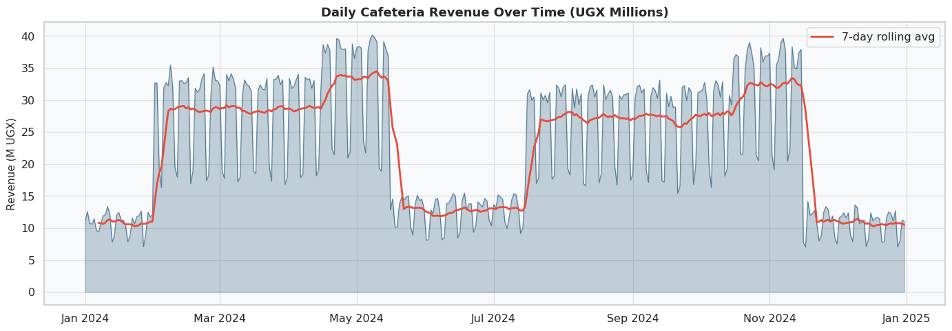
Figure 1: Time series of daily total revenue generated by the cafeteria with a 7-day rolling average overlay. The area under the curve highlights daily revenue fluctuations, while the rolling average smooths out the short-term volatility revealing underlying trends and patterns over the t
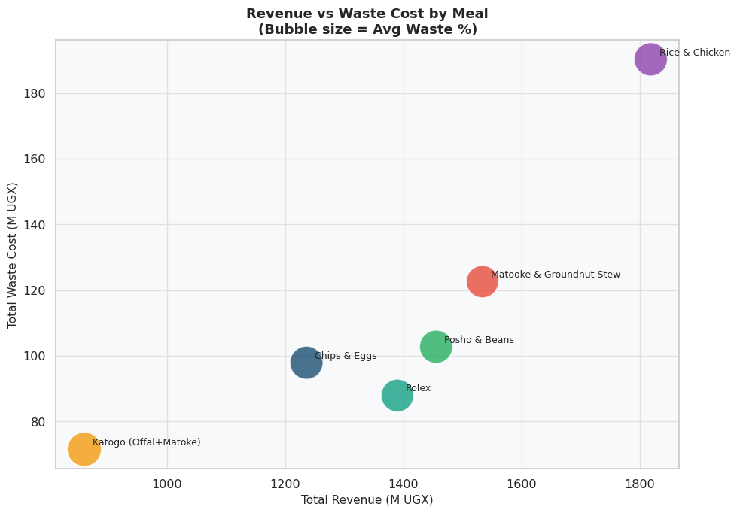
Figure 2: Scatter plot comparing total revenue and total waste cost for each meal type at the cafeteria. Each point represents a meal, with its position indicating the balance between revenue and waste cost.
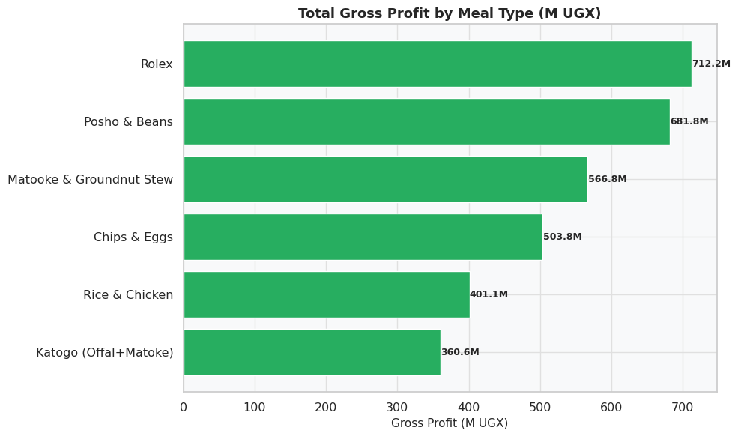
Figure 3: Horizontal Bar chart showing total gross profit in million UGX shillings for each meal type at the cafeteria. Bars are colored green for positive profit. This visualization highlights which meals are the most and least profitable, providing insights for menu optimization and cost management.

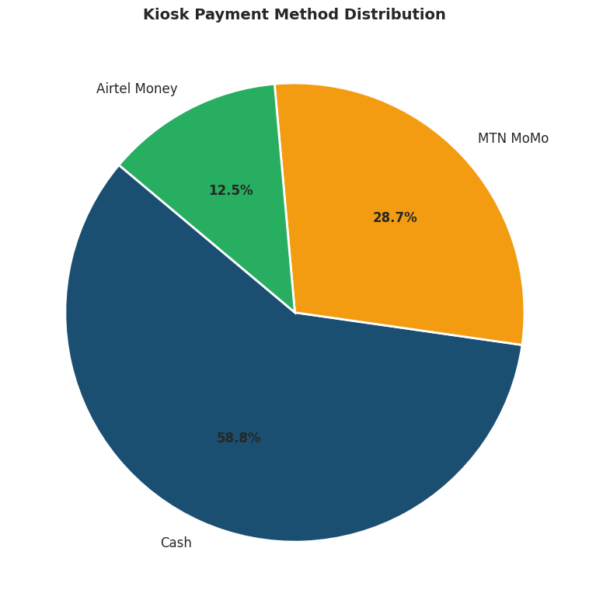
Figure 4: A Pie chart showing distribution of payment methods used at the kiosks. This visualization reveals the relative popularity of cash versus mobile money payments among students informing decisions on payment infrastructure and potential promotions to encourage preferred payment methods.
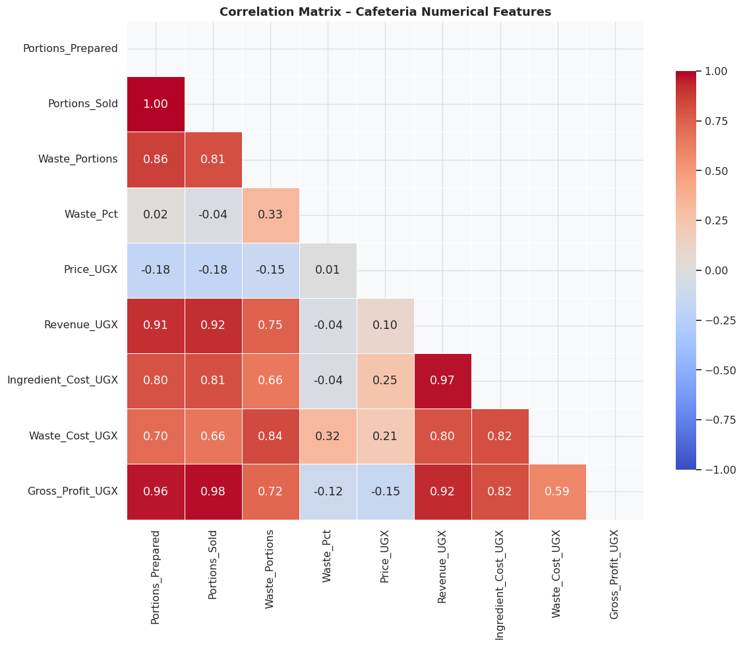
Figure 5: Correlation heatmap showing the relationships between key numerical features in the cafeteria dataset. The visualization helps identify which factors are most strongly associated with revenue and waste, providing insights for operational improvements and strategic decision making.

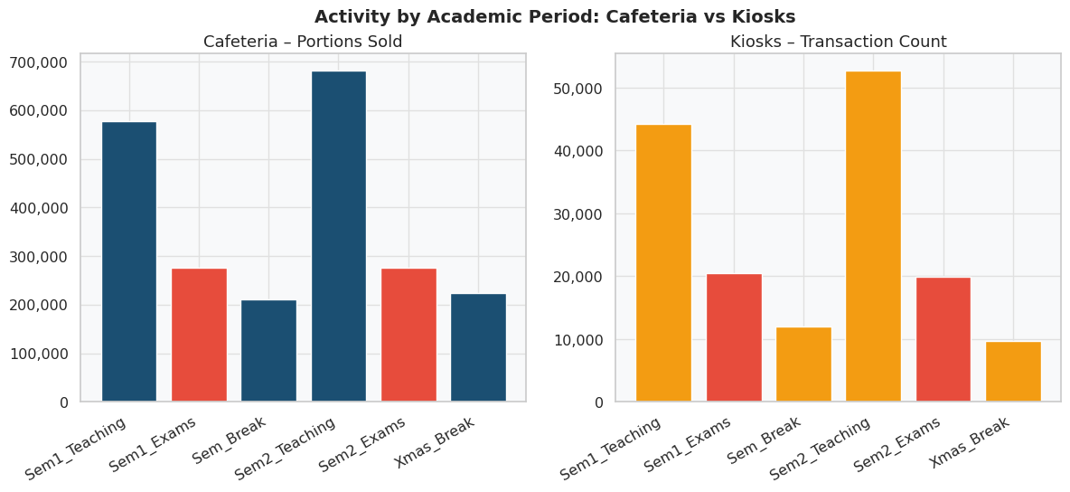
Figure 6: Side by side bar charts comparing cafeteria portions sold, and kiosk transaction counts across different academic periods. This visualization reveals how student activity at both the cafeteria and kiosks fluctuates throughout the academic calendar, highlighting periods of high demand.
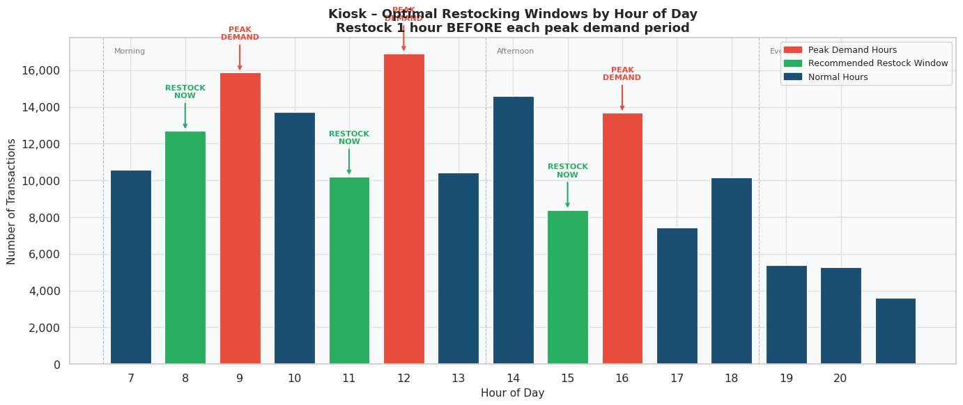
Figure 7: The spaced bar graph shows the Optimal Restocking Windows by Hour of Day
The analysis is explained below:
A. DEMAND-SUPPLY MISMATCH
Comparisons of portions prepared against portions sold across all 6 meal types reveal consistent and systematic overproduction. Protein based dishes particularly Rice and Chicken and Matooke and Groundnut stew, exhibit for all meal types, confirming that the mismatch is structural rather than occasional. The correlation matrix of cafeteria numerical features confirms a strong positive correlation between Portions Prepared and Waste Portions while Gross Profit shows a negative correlation with Waste_Pct , directly lining waste to profit erosion.
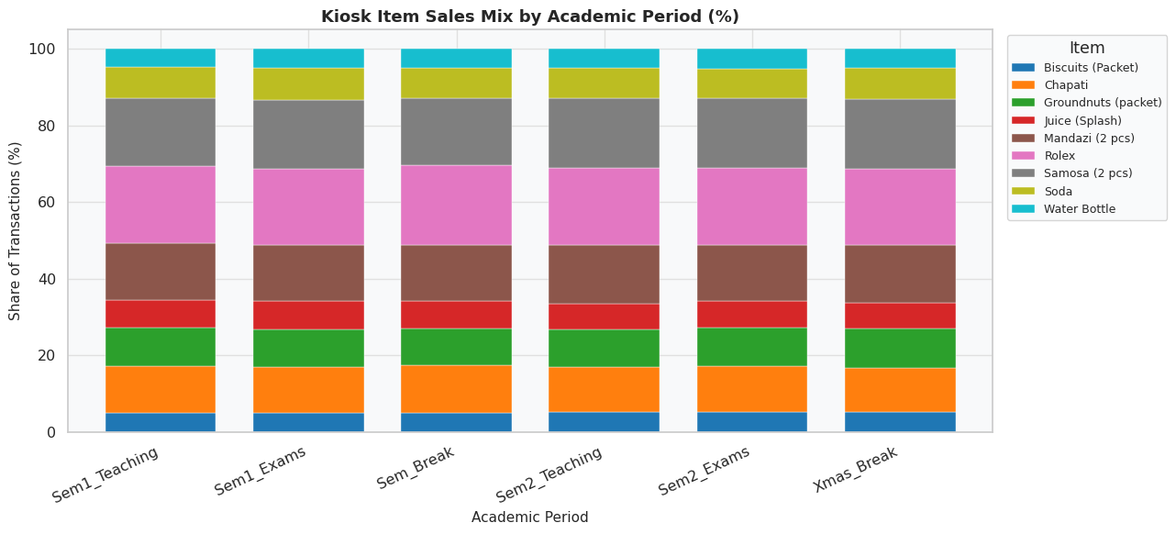
Figure 8: Stacked bar chart showing the percentage share of each item sold at the kiosks across different academic periods. This visualization reveals how the popularity of different items changes throughout the academic calendar, providing insights for inventory management and potential menu adjustments to better meet student demand
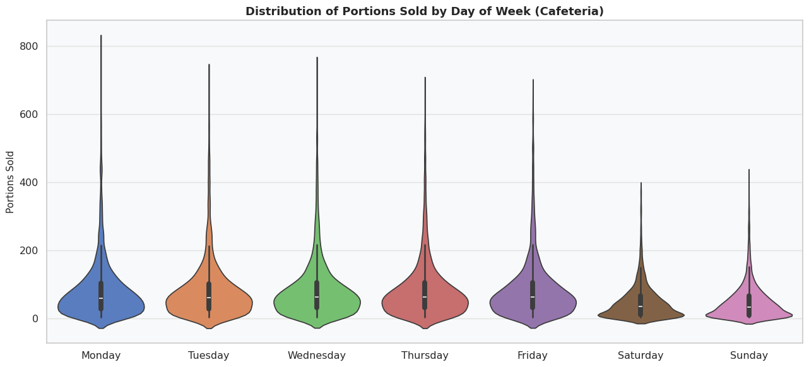
Figure 9: Violin plot showing the distribution of portions sold for each day of the week at the cafeteria. The width of each violin indicates the density of transactions at different portions, while the embedded box plot shows the medium and interquartile range. This visualization reveals how sales volume varies throughout the week, informing staffing and inventory decisions to better meet demand on busier days.
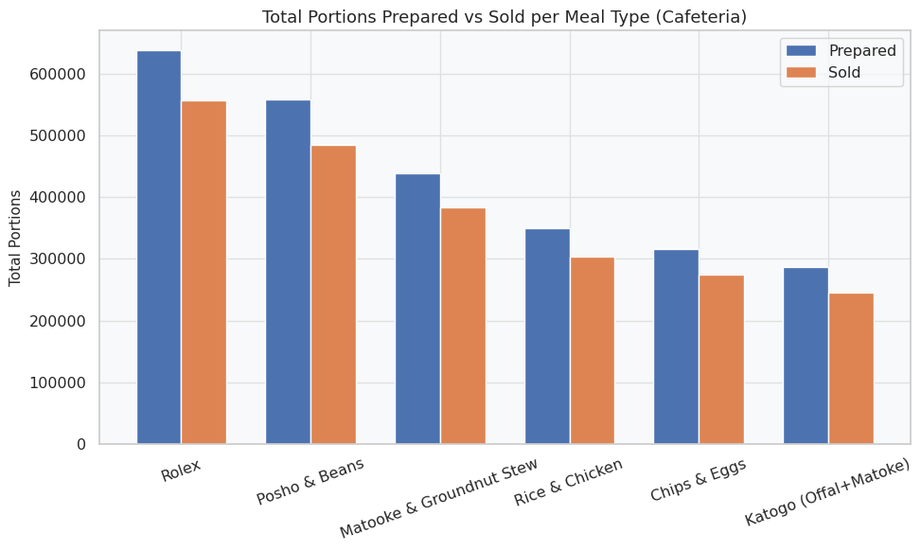
Figure 10: This bar plot compares the total portions prepared and sold for each meal type in the synthetic cafeteria data set. The ‘prepared’ bars show the total number of portions made, while the ‘sold’ bars indicate how much was actually sold. This visualization helps identify the meals have high waste (large gap between prepared and sold) and which are more popular (smaller gap)
B. WASTE PERCENTAGE DISTRIBUTION
Waste percentages exhibit high variability across the dataset. Median waste across meals hovers around 12-15%, but certain categories produce tail events exceeding 35%. Boxplots ordered by median waste percentage show that Katogo (Offal+Matooke) and Rice and Chicken carry the widest interquartile ranges, making them the hardest to plan. The plots confirm that no meals waste distribution is tightly concentrated, all curves are broad, is that high revenue meal simultaneously generate the highest absolute waste costs, underscoring the importance of analyzing net profitability rather than gross revenue.
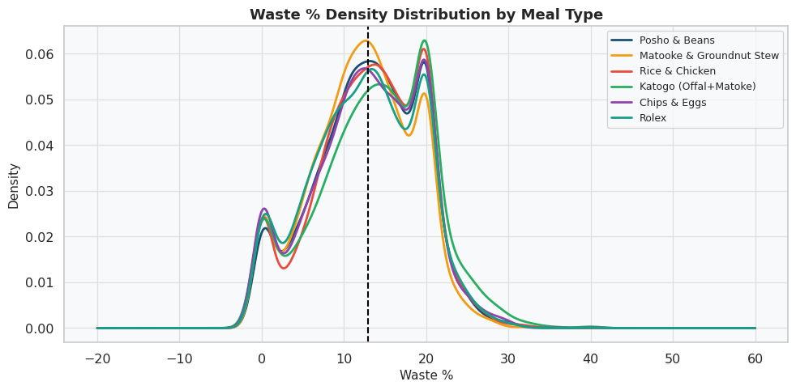
Figure 11: Kernel density plot showing the distribution of waste percentage (Waste_Pct) for each meal type at the cafeteria. This visualization helps identify which meals have higher variability in waste, and which are more consistently low or high in waste, providing insights for mental optimization and waste reduction strategies.
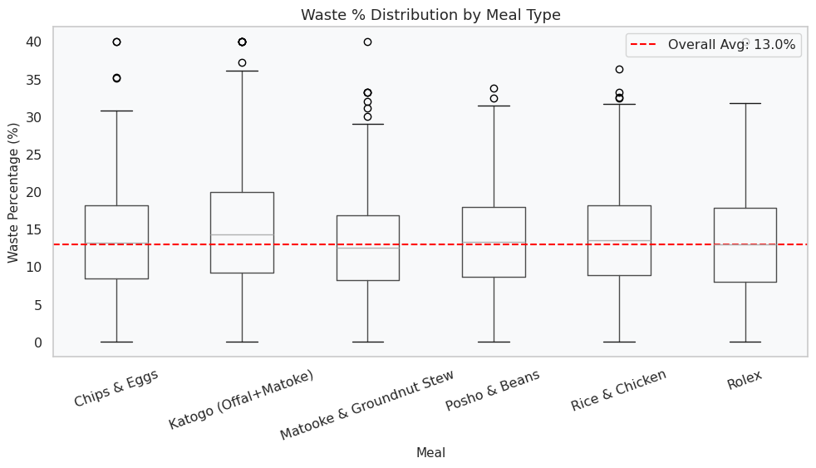
Figure 12: Distribution of waste percentage (Waste_Pct) across meal types at Makerere University cafeteria, ordered from highest to lowest median waste.
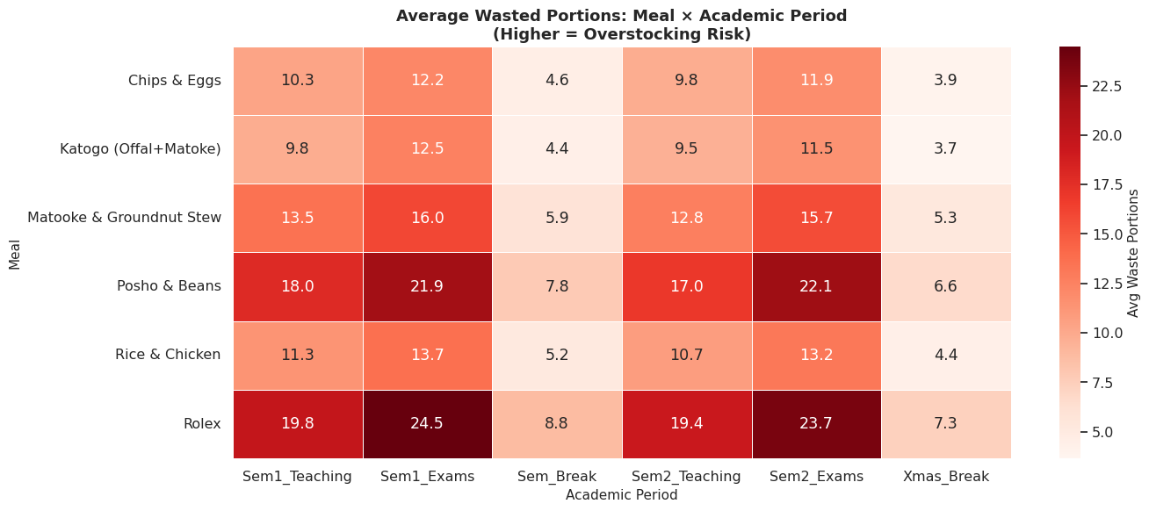
Figure 13: Heatmap showing the average number of wasted portions for each meal type across different academic periods. Darker shades indicate higher average waste signaling potential stocking issues. This visualization helps identify which meals are at most risk of over production during specific periods, informing adjustments to preparation quantities to reduce waste and improve efficiency.
TABLE II: SUMMARY OF KEY EDA FINDINGS
DIMENSION | KEY FINDING | IMPLICATION
Demand-Supply | Surplus>20% for key meals | Forecasting is needed
Waste | High levels of waste about 60% | Tail risk management
Revenue |  | Day based planning
Hourly Demand |  | Time aware restocking
Ingredient Use |  | Procurement optimization

- VIII. MULTI-MODEL CLUSTERING ARCHITECTURE
The project work was explored through four clustering models that address different parts of the food supply chain problem: HDBSCAN, Spectral Clustering, Agglomerative Clustering, and BIRCH. Together, they support the analysis of operational structure, noise, and segmentation across cafeteria days.
A. HDBSCAN Model
HDBSCAN was used to cluster cafeteria days into operational groups without forcing all days into a fixed number of clusters.
This model is important because it separates normal teaching days, high-volume hub days, and noise or unusual days such as breaks or atypical activity.
Unlike models that require labeled outputs, HDBSCAN is robust to noisy operational data and can surface break-period days that need manual procurement review.
The current deployment uses this model because the project needs fast inference, membership strength scores, and a practical way to route each new cafeteria day to a supply action.
B. Spectral Clustering Model
Spectral Clustering was used to detect non-linear groupings in the cafeteria data by relying on the similarity structure between days rather than direct distance alone.
It is helpful when the day types are not well separated by simple geometric boundaries and when the supply pattern depends on relationships hidden in the feature space.
In this project, Spectral Clustering helped test whether the operational days naturally form graph-like groups under the academic calendar and demand patterns.
C. Agglomerative Clustering Model
Agglomerative Clustering was used to build a hierarchy of cafeteria-day groups by merging similar observations step by step.
This method is useful for explaining how small operational groups combine into larger structures and for checking whether the data contains nested demand patterns.
The model gave the team a clear hierarchical view of the campus food demand landscape and helped validate whether the daily records could be organized from fine-grained to broad clusters.
D. BIRCH Model
BIRCH was used because it scales well to larger datasets and incrementally summarizes the data into compact subclusters.
This makes it a practical choice for food supply data where records can grow quickly and where the model must remain efficient during repeated updates.
In this project, BIRCH supported fast clustering over the engineered cafeteria-day feature matrix and provided a lightweight comparison against the density-based and hierarchical methods.
E. Model Integration
The value of the four-model approach is that each model answers a different question. HDBSCAN handles density-based grouping and noise, Spectral Clustering captures non-linear partitions, Agglomerative Clustering exposes hierarchical structure, and BIRCH provides scalable incremental grouping.
This division of labor makes the project easier to defend academically and more practical operationally because the final supply decision can be traced back to a model purpose rather than a single black-box output.
IX. MODEL ASSESSMENT AND PENALTY INTERPRETATION
Model selection in this project was guided by assessment penalties rather than by raw accuracy alone. In food supply chains, a bad cluster assignment is costly when it creates overproduction, waste, stock-outs, or manual rework.
For HDBSCAN, the assessment was based on cluster quality. The silhouette score of 0.5043, Davies-Bouldin index of 0.6632, and Calinski-Harabasz score of 1,486.5 indicate reasonably separated clusters with useful structure for operational decision making.
The noise rate of 25.7 percent is not a failure in this context. It is a penalty signal that flags unusual or low-confidence days for manual review and minimum stock rather than forcing an incorrect cluster assignment.
For Spectral Clustering, the main penalty was sensitivity to affinity construction and the need to tune the similarity graph carefully. When the graph is poorly specified, the resulting clusters become unstable and less interpretable.
For Agglomerative Clustering, the penalty is that once merges are made they cannot be undone, so early mistakes can distort the final cluster tree. That makes the model valuable for interpretation but more fragile if the hierarchy is not well chosen.
For BIRCH, the penalty is that strong compression can blur smaller distinctions in the data. It is efficient and scalable, but its summaries must be chosen carefully to avoid losing operational nuance.
Taken together, the assessment penalties show why the deployed path uses HDBSCAN and not the other clustering models. The deployment goal is not just segmentation quality but safe procurement decisions under uncertainty.
X. DEPLOYMENT ARCHITECTURE
The deployed system is implemented as a FastAPI application in app.py and packaged with a Docker-based runtime for reproducibility.
At startup, the service loads model/hdbscan_model.pkl, model/scaler.pkl, and model/cluster_info.json, then exposes them through HTTP endpoints that the front-end can call.
Incoming cafeteria records are normalized into the expected feature order, scaled with the saved StandardScaler, and passed to hdbscan.approximate_predict so that new days can be classified without retraining.
The main prediction endpoint returns the cluster id, cluster name, confidence, membership strength, and the supply action attached to that cluster. This makes the output useful to a vendor instead of just being a raw model label.
The application also exposes operational endpoints for the dashboard, inventory, suppliers, and procurement workflow. That means the deployment is not only a predictor; it is a small supply chain management service.
The user interface is served from templates/index.html and static assets under static/, while the API provides the data that powers the dashboard and procurement forms.
- The Dockerfile trains the model during image build, copies the trained artifacts into the image, and starts Gunicorn with a Uvicorn worker class. That keeps the runtime self-contained and avoids manual model setup after deployment.
- The test_api.py script verifies the health check, cluster definitions, dashboard, inventory alerts, and prediction path. It is useful for confirming that the deployed service still behaves correctly after changes.
In deployment terms, the system follows a simple and defensible path: data entry, preprocessing, scaling, clustering, cluster-based supply advice, and operator review for noisy cases.
XI. LIMITATIONS AND CONCLUSION
The first limitation is that the datasets are synthetic, so the models inherit assumptions from the generator and may understate real-world randomness.
The second limitation is the cold-start problem. Even a well-trained model can underperform when the first live data points diverge from synthetic patterns.
The third limitation is that external variables such as weather, campus events, and live enrollment were not integrated, even though they may affect cafeteria demand.
Despite those limits, the project establishes a strong foundation for a decision-support system that is easier to explain, easier to deploy, and more useful than a single forecast number alone.
In conclusion, the four-model architecture supports the full workflow from segmentation to clustering to anomaly screening. The deployment layer then turns those results into a usable service for food vendors around Makerere University.
The current build is therefore not just an academic model collection. It is a working prototype that shows how structured EDA, assessment penalties, and deployment design can be combined into a practical food supply chain tool.

In conclusion, this study establishes the empirical architectural foundations for a Smart Food Supply Chain Management System targeting cafeterias and kiosks in Makerere University. Through structured exploratory data analysis of cafeteria and kiosk datasets, comparing 28 visualizations and a systematic feature engineering pipeline, we have documented four categories of operational inefficiency: systematic demand-supply mismatch, high-variability waste percentages with disproportionate financial impact, weekday-structured revenue cycles, and time-clustered transaction demand aligned with academic schedules. These findings confirm that current food supply operations are reactive rather than predictive, and the underlying demand patterns are sufficiently regular to support effective machine learning-based clustering and decision support in the planned next phase.
REFERENCES
[1] U. von Luxburg, "A tutorial on spectral clustering," Statistics and Computing, vol. 17, no. 4, pp. 395-416, 2007.
[2] F. Murtagh and P. Contreras, "Algorithms for hierarchical clustering: an overview," Wiley Interdisciplinary Reviews: Data Mining and Knowledge Discovery, vol. 2, no. 1, pp. 86-97, 2012.
[3] G.E. Box, G.M.Jenkins, G.C. Reinsel, and G. M. Ljung, "Time Series Analysis: Forecasting and Control 5th ed. Hoboken,NJ,USA: Wiley, 2015.
[4] R.Jha et., Handbook on Food. Cheltenham, U.K.: Edward Elgar Publishing, 2014.
[5] Assembly of Life Sciences (U.S), Assessing Changing Food Consumption Patterns. Washington, DC, USA: National Academy Press,1981.
[6] L. McInnes, J.Healy, and S.Astels, “HDBSCAN: Hierarchical density based clustering,” J.Open Source Softw.,vol.2, no.11, p.205,2017.
[7] T. Zhang, R. Ramakrishnan, and M. Livny, "BIRCH: An efficient data clustering method for very large databases," in Proc. ACM SIGMOD, 1996, pp. 103-114.
[8] Y. Zhao, K.Liu,and M.Liu,”Reducing food waste in campus dining: A data-driven approach to demand prediction and sustainability,”Sustainability, vol.17,no.2,p.379,2025.
[9] D. Mmereki, V.E David, and A.H.W.Brownell,”The management and prevention of food losses and waste in low-and-middle-income countries: A mini-review in the Africa region, “Waste Manag.Res., vol.42,no.1,pp.3-17,2024.
[10] S.K. Panda and S.N. Mohanty, ”Time series forecasting and modelling of food demand supply chain based on regressors analysis,IEEE Access,col.11,pp.42679-42700, 2023
[11] N. Nassibi.H. Fasihuddin, and L.Hasairi, “Demand forecasting models for food industry by utilizing machine learning approaches, “Int.J.Adv.Comput.Scio.Appl., vol.14, no.3, pp.892-898, 2023
[12] M. Seyedan and F. Mafakheri, "Predictive big data analytics for supply chain demand forecasting: Methods, applications, and research opportunities," J. Big Data, vol. 7, no. 1, pp. 1–22, 2020.
Rugambwa Gloria is a student in Software Engineering at Makerere University. Her research interests include machine learning applications in resource-constrained environments and smart systems design.
Ainembabazi Martina is a student in Software Engineering at Makerere University. Her research focus includes data analysis, intelligent systems, and sustainable technology.
Namitto Maria Leodesca is a student of Software Engineering at Makerere University. Her research focus includes exploratory data analysis, food systems technology, and human-computer interaction in emerging markets.

